Spring Boot Microservices:
Spring Boot microservices typically follow a modular, layered structure for scalability and maintainability, with each service having its own independent project. The project starts from a main class annotated with @SpringBootApplication.
Project Structure:
A standard Spring Boot microservice project uses Maven or Gradle with a clear separation of concerns. The root package (e.g., com.example.service) holds the main class, while subpackages organize code by layer.
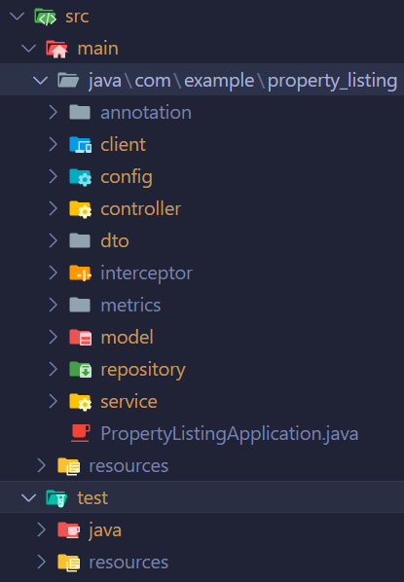
my-microservice/
├── pom.xml (or build.gradle)
├── src/
│ └── main/
│ ├── java/
│ │ └── com/example/service/
│ │ ├── ServiceApplication.java (main class)
│ │ ├── controller/ (REST controllers)
│ │ ├── service/ (business logic)
│ │ ├── repository/ (data access)
│ │ ├── model/ or entity/ (domain models)
│ │ ├── dto/ (data transfer objects)
│ │ └── config/ (configurations)
│ └── resources/
│ ├── application.properties/yml (configs)
│ ├── static/ (CSS, JS, images)
│ └── templates/ (Thymeleaf/FreeMarker views)
└── src/test/ (unit/integration tests)

Controllers Package:
This folder holds REST API endpoints that receive HTTP requests from clients or gateways. Classes here use @RestController or @Controller annotations, map requests via @GetMapping/@PostMapping, validate inputs with @Valid, and delegate to services. Example: UserController.java exposes /users endpoints.

Service Package:
Contains business logic implementation, orchestrating operations across repositories and external calls. @Service-annotated classes handle validation, transactions (@Transactional), and complex rules e.g., UserServiceImpl.java computes user profiles by combining repository data. Interfaces may sit here too, with concrete impls in a subfolder.
Repository Package:
Manages data access and persistence using Spring Data JPA or other providers. @Repository-annotated interfaces extend JpaRepository for CRUD ops—e.g., UserRepository.java defines findById() or custom @Query methods. Keeps controllers/services database-agnostic.
Model/Entity Package:
Stores domain classes representing database tables or core business objects. @Entity-annotated POJOs with JPA annotations like @Id, @Column map to DB schemas—e.g., User.java defines fields like id, name. Use Lombok (@Data) for getters/setters.
DTO Package:
Holds Data Transfer Objects for API payloads, decoupling external interfaces from internal entities. Plain POJOs like UserDto.java with Jackson annotations (@JsonProperty) avoid exposing sensitive entity fields and enable versioning—e.g., mask password in responses.
Config Package:
Centralizes Spring configuration beans, security setups, and customizers. @Configuration classes define @Beans for datasources, interceptors, or Swagger—e.g., SecurityConfig.java with @EnableWebSecurity or DatabaseConfig.java.

